Gallery of Gardens”
A National Garden Club Standard Flower Show
Sponsored by Holland Garden Club.

May 6-9, 2025

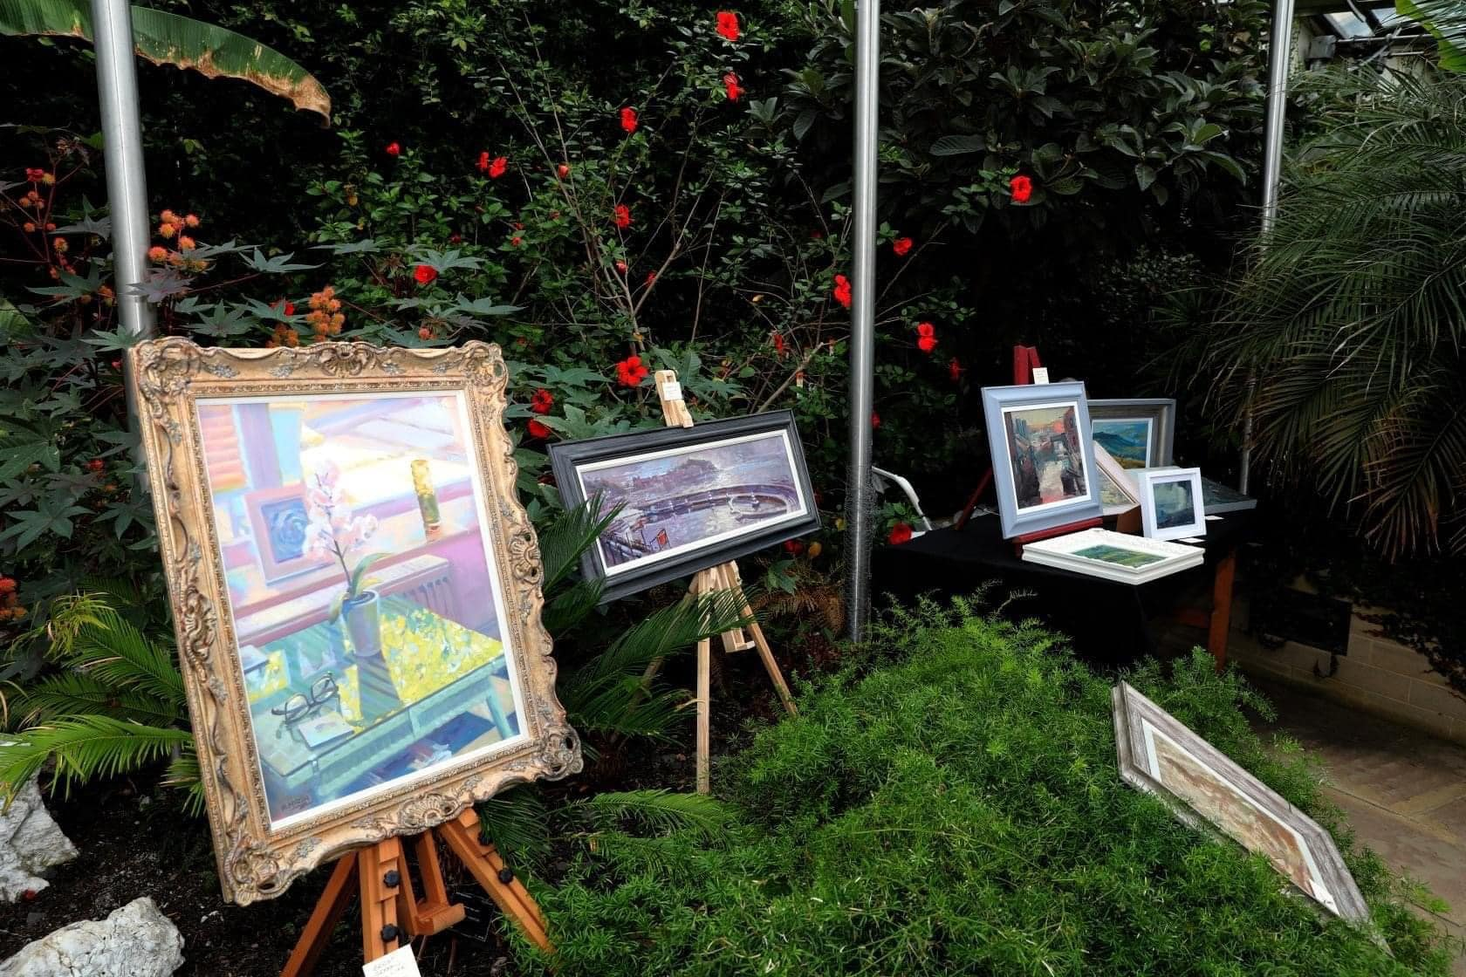

Flower Show open May 6, 2025

First opens to public at 3pm-6 pm Tuesday, May 6, 2025
9am-5pm Wednesday-Friday, May 7-9, 2025

Open to the public Free of Charge
Holland Armory
16 W 9th Street, Holland, Michigan 49423
Member of National Garden Clubs, Clubs of Central Region, Michigan Garden Clubs, District 4

